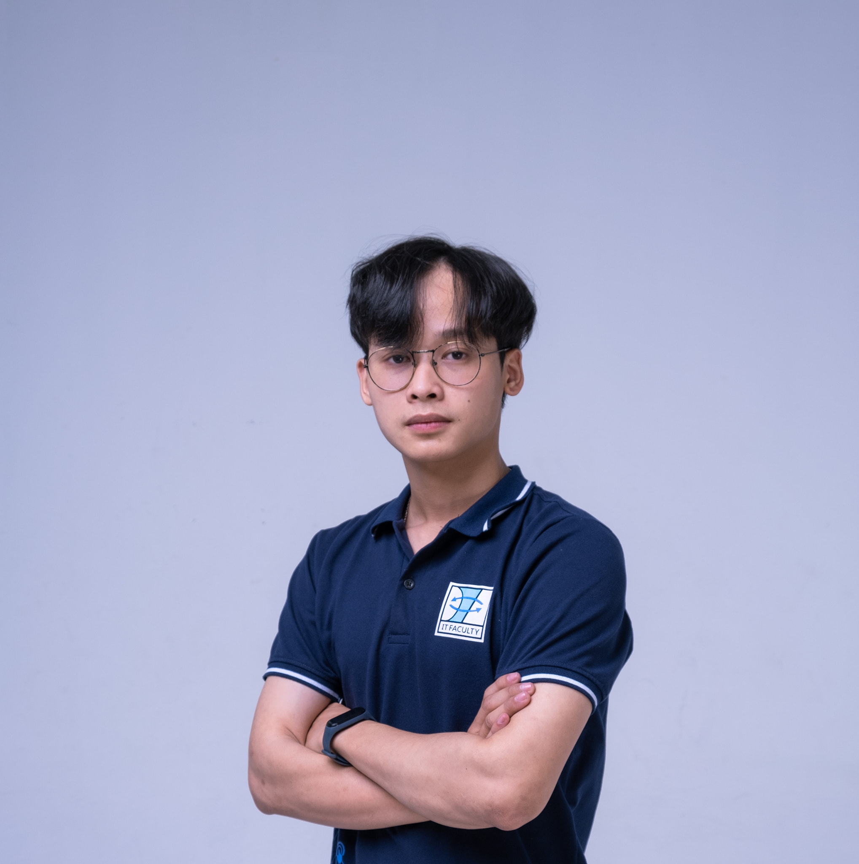

# **EDUCATION**

**VIEN MAI**

SOFTWARE ENGINEER



 +84 869040015

11 Suong Nguyet Anh, Hoa Hai Bac, Son tra, Da Nang, Viet Nam

 Maithevien9[@](mailto:son.tran@team.enouvo.com)gmail.com

| **DANANG UNIVERSITY OF**  **TECHNOLOGY** | Bachelor of Engineering, Computer Science & Engineering. |
| --- | --- |

# **WORK EXPERIENCE**

| **ENOUVO IT SOLUTIONS**  *Da Nang, Viet Nam April 2022 – Present* | **FRONTEND ENGINEER**   * Maintained and Developed Frond End with ReactJS, NextJS, * Apply technologies to the project including Testing, GraphQL, Typescript, Apollo * Refactored the old codebase for maintaining and scaling * Learn and practise on Blockchain |
| --- | --- |
| **CORIZE**  *Da Nang, Viet Nam April 2021 – April 2021* | **FULLSTACK SOFTWARE ENGINEER**   * Maintained and Developed Frond End with ReactJS, NextJS, * Developed Mobile with React Native * Maintained and developed Back End by using ExpressJs, MongoDB, MySQL, Cloudinary * Typescript, Redux Toolkit, Ant Design * Initial source code and research new technology for project * Setup CI/CD for testing and deploy with CircleCI * Setup Firebase, Heroku, AWS lambda for hosting web page |

# **PROJECTS**

## **ACCIONA**

*April 2022 – now*

A management platform helps construction company to manage their employees with timesheet, manage other modules and their partners.

**Technical:** Typescript, ReactJs, Mapbox

## **LIXIL**

*Jan 2022 – April 2022*

Website helps users to create drawings, interior design such as cabinets, wall shelves, making it easy for stores to grasp the needs of users.

**Technical:** Typescript, ReactJS, Redux toolkit, Antd design, Nodejs, Cloudinary, Firebase, Heroku, CircleCI

[lixil simulation](https://www.lixil.co.jp/lineup/kitchen/s/canor/simulation/#/)

## **VOXONOTE**

*Oct 2021 – Dec 2021*

A music entertainment website that helps users to enjoy latest, trending music and upload audio and enjoy it

**Technical:** Typescript, ReactJS, NextJS, Redux toolkit, Antd design

## **MONLALUXE**

*Jul 2021 - Dec 2021*

An order management project, helping users to manage their sales process more conveniently.

**Technical:** Typescript, ReactJS, Redux toolkit, Antd design, Nodejs, SocketIO, Cloudinary

## **CORAL**

*Sep 2020 – March 2021*

An e-commerce project with the user being a store and a customer, making food easy for users to access

**Technical:** Typescript, React native, Redux toolkit, UI kitten, Storybook

## 

## **SLACK BOT**

*Sep 2020 – March 2021*

A project for organization in Slack, notifying multiple channels within the organization, making it easy for admins to communicate information across channels.

**Technical:** Typescript, Nodejs, Google sheets Apis, Slack, AWS lambda, Google Cloud Platform, Hero

# **SKILLS**

| **Software**:  Visual Code, Jira, Slack, Figma, Postman, Github, Gitlab | **Language**:  Javascript, Typescript, Solidity, HTML, CSS | **Technology:** ReactJS, NextJS, Typescript, GraphQL, AWS, NodeJS, MongoDB, React Native, Gatsby, Mapbox, Firebase, Webpack, Vite, Babel, Antd, UI kitten, Storybook, Material UI, Apollo, Hardhat | |
| --- | --- | --- | --- |
| **Soft Skills:**  Teamwork | Organization Skills | Communication | Critical Thinking |
| Problem Solving | Research Skill | Attention to detail | Design Thinking |

